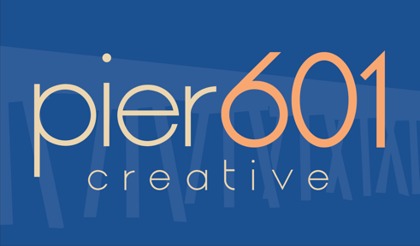
APPLICATION FOR Pier601 Creative
Email all materials to persuitj@uncw.edu and sudnickk@uncw.edu
For priority consideration, applications are due on May 1 (for Fall Semester) or December 1 (for Spring Semester) by 11:59 p.m.

Application Directions:
- Review the Pier601 Creative website at www.pier601creative.com
- Prepare your application packet. It must include:
  - This cover sheet
  - A current resume
  - A cover letter
  - A sample of your work (video, writing, research, etc.)
  - A current printer-friendly degree audit
- Your cover letter should be addressed to Dr. Persuit and Dr. Sudnick and include/address the following:
  - Why you want to be in Pier601 Creative
  - What skills, abilities, or other attributes that you would bring to the team
  - What your Forté primary strength is and what that means in terms of how you work with groups
APPLICANT NAME:
YEAR:
850#:
MAJOR(S):
MINOR(S):
CURRENT GPA:
EMAIL ADDRESS:
LINK TO ONLINE PORTFOLIO OR LinkedIn URL if you have one (encouraged but not required)
List a faculty member in the Department of Communication Studies* who could attest to the competency of the skills or abilities you would bring to the team
*if you are not a COM major, list a faculty member in your major.
INCOMPLETE APPLICATIONS WILL NOT BE CONSIDERED

